408410056 許庭涵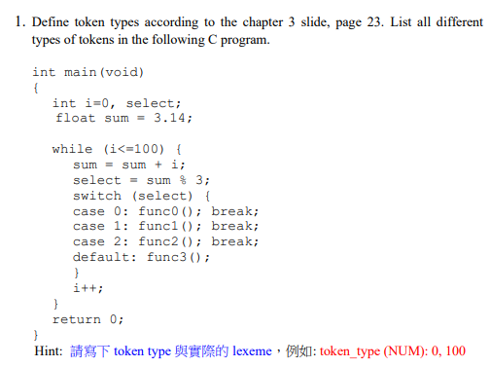

token_type (INT) int

token_type (BLANK) ' ', '\t', '\n'

token_type (MAIN) main

token_type ( ( ) (

token_type (void) void

token_type ( ) ) )

token_type ( = ) =

token_type ( ; ) ;

token_type (FLOAT) float

token_type (WHILE) while

token_type (NUM) 0, 3.14, 100, 3, 1, 2

token_type (ID) i, select, sum

token_type (<=) <=

token_type (+) +

token_type (%) %

token_type (SWITCH) swtich

token_type ( { ) {

token_type ( } ) }

token_type (CASE) case

token_type ( : ) :

token_type (FUNC0) func0()

token_type (FUNC1) func1()

token_type (FUNC2) func2()

token_type (FUNC3) func3()

token_type (BREAK) break

token_type (DEFAULT) default

token_type (++) ++

token_type (RETURN) return

token_type ( , ) ,



(a) all strings of 0's and 1's and end with string 00

(b) all strings begin with ab and follow by 0 or more b and end by a

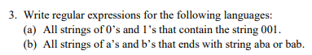

(a) (0|1)*001(0|1)*

(b) (a|b)*(aba|bab)